Allyson Totpal

CIS-535

January 19,2025

Dear Bob,

I appreciate the opportunity to work on developing a database solution for your business, Bob’s Home Repairs. Currently your business operations are manually tracked, which can lead to limited business growth due to how time-consuming it can be. Based on your business outline and analysis of business operations, I have designed a structured and efficient database system to help you streamline business processes, improve record-keeping, and enhance productivity.

Key Features:

1. Customer & Bids Management - A structured way to store customer information and track bids for home repairs where each bid is associated with a customer, allowing for easy retrieval and management.

2. Repair Tracking - Once a bid has been accepted, repairs associated with that big are logged into the system to make it easy to monitor their progress.

3. Material & Supplier Management - The database will maintain records of materials used for each repair and their respective suppliers to help track inventory, costs, and supplier relationships.

4. Payment Tracking - The system enables tracking of payments made by customers to ensure an organized billing process. A similar payment system is also recorded for suppliers.

Deliverables

- Entity-Relationship Diagram (ERD) to outline the structure of the database, detailing entities and their relationships.

- Third normal form ERD to ensure efficient data organization and integrity, with necessary primary and foreign keys established.

- SQL queries to retrieve essential business information efficiently to help with decision-making and record-keeping.

This software package consolidates all project elements into a structured document, making it easy for you to review and use. The benefits this can bring to your business include eliminating the need for manual bookkeeping to reduce errors and save you time, providing a structured way to store and retrieve business data efficiently, enhancing financial tracking for both customer and supplier payments, and scalability of your business to allow for you to manage more customers and repairs jobs seamlessly.

Thank you for the opportunity to contribute to your business’s success and I look forward to your feedback and assisting with implementation as needed.

**ERD**

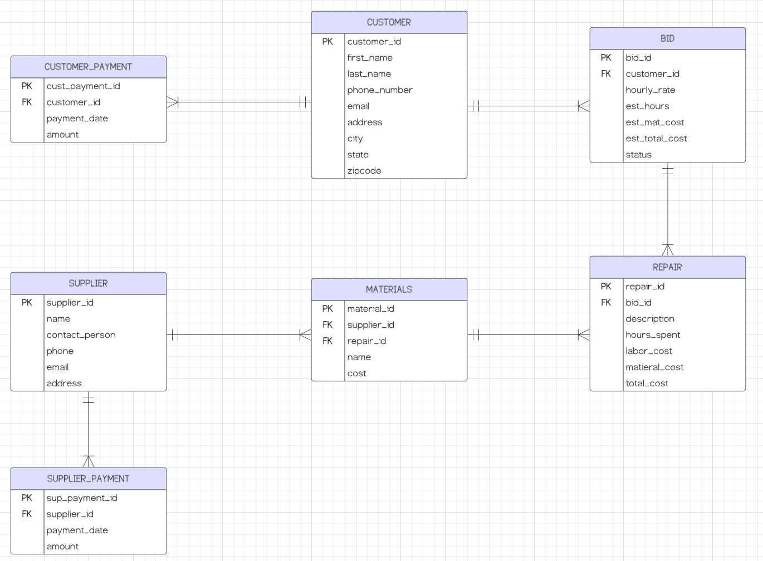

**Third Normal Form ERD**

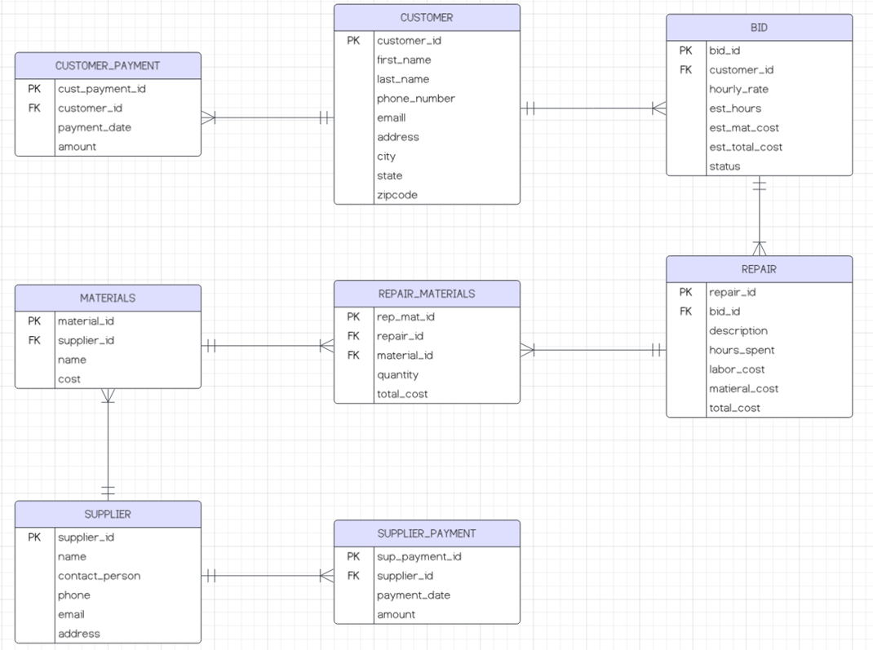

**DDL - Creation of Tables**

create table Customers (

customer_id int primary key,

first_name varchar(30) not null,

last_name varchar(30),

phone varchar(20),

email varchar(50),

address text

)

create table Bids (

bid_id int primary key,

customer_id int foreign key references Customers(customer_id),

hourly_rate float not null,

est_hours float not null,

est_mat_cost float not null,

est_total_cost float not null,

status varchar(50) not null

)

create table Repairs (

repair_id int primary key,

bid_id int foreign key references Bids(bid_id),

description text not null,

hours_spent float,

labor_cost float,

material_cost float,

total_cost float

)

create table Suppliers (

supplier_id int primary key,

supplier_name varchar(100) not null,

contact_name varchar(50),

phone varchar(20),

email varchar(50),

address text

)

create table Materials (

material_id int primary key,

supplier_id int foreign key references Suppliers(supplier_id),

material_name varchar(200) not null,

cost float not null

)

create table RepairMaterials (

rep_mat_id int primary key,

repair_id int foreign key references Repairs(repair_id),

material_id int foreign key references Materials(material_id),

quantity int not null,

cost float not null

)

create table SupplierPayments (

sup_payment_id int primary key,

supplier_id int foreign key references Suppliers(supplier_id),

payment_date date not null,

amount float not null

)

create table CustomerPayments (

cust_payment_id int primary key,

customer_id int foreign key references Customers(customer_id),

payment_date date not null,

amount float not null

)

**DML - Inserting Records**

insert into Customers(customer_id, first_name, last_name, phone, email, address) values

(1, 'Jane', 'Wozowski','9485559386', 'jane.wozowski@ex.com', '104 Elm Street, Anaheim, CA 92807'),

(2, 'Mike', 'Sulley', '71455510234', 'mike.sulley@ex.com', '238 Oak St, Anaheim, CA 92812'),

(3, 'Elsie', 'Silver', '7145552856', 'elsie.silver@ex.com', '9238 Pine Avenue, Anaheim, CA 92804'),

(4, 'Lyla', 'Sage', '7145552395', 'lyla.sage@ex.com', '7844 Acacia Drive, Anaheim, CA 92817'),

(5, 'Tom', 'Matson', '7145556235', 'tom.matson@ex.com', '29345 Maple Ave, Anaheim, CA 92801')

insert into Bids(bid_id, customer_id, hourly_rate, est_hours, est_mat_cost, est_total_cost, status) values

(1, 1, 50.00, 10, 200.00, 700.00, 'Pending'),

(2, 2, 55.00, 8, 150.00, 590.00, 'Accepted'),

(3, 3, 60.00, 12, 300.00, 1020.00, 'Rejected'),

(4, 4, 50.00, 5, 100.00, 350.00, 'Completed'),

(5, 5, 65.00, 7, 250.00, 705.00, 'Accepted')

insert into Repairs(repair_id, bid_id, description, hours_spent, labor_cost, material_cost, total_cost) values

(1, 1, 'Fix plumbing leak', 10, 500.00, 200.00, 700.00),

(2, 2, 'Install new roof', 8, 440.00, 150.00, 590.00),

(3, 3, 'Paint exterior', 12, 720.00, 300.00, 1020.00),

(4, 4, 'Replace flooring', 5, 250.00, 100.00, 350.00),

(5, 5, 'Repair foundation', 7, 455.00, 250.00, 705.00)

insert into Suppliers(supplier_id, supplier_name, contact_name, phone, email, address) values

(1, 'Home Depot', 'Alice Brown', '7145551239', 'alice@homedepot.com', '101 Main St'),

(2, 'Lowes', 'Bob Green', '7145553284', 'bob@lowes.com', '983 South St'),

(3, 'Ace Hardware', 'Charlie White', '7145559123', 'charlie@acehardware.com', '1430 East St'),

(4, 'Ganahl Lumber', 'David Black', '7145555648', 'david@ganahllumber.com', '986 West St'),

(5, 'Harbor Freight', 'Eve Red', '7145553291', 'eve@harborfreight.com', '55 North St')

insert into Materials(material_id, supplier_id, material_name, cost) values

(1, 1, 'Nails', 5.00),

(2, 1, 'Lumber', 20.00),

(3, 2, 'Paint', 30.00),

(4, 3, 'Tiles', 25.00),

(5, 4, 'Cement', 15.00),

(6, 5, 'Screws', 6.00)

insert into RepairMaterials(rep_mat_id, repair_id, material_id, quantity, cost) values

(1, 1, 1, 10, 50.00),

(2, 2, 2, 5, 100.00),

(3, 3, 3, 3, 90.00),

(4, 4, 4, 4, 100.00),

(5, 5, 5, 6, 90.00)

insert into SupplierPayments(sup_payment_id, supplier_id, payment_date, amount) values

(1, 1, '2025-01-01', 200.00),

(2, 2, '2025-01-05', 150.00),

(3, 3, '2025-01-10', 300.00),

(4, 4, '2025-01-15', 100.00),

(5, 5, '2025-01-20', 250.00)

insert into CustomerPayments(cust_payment_id, customer_id, payment_date, amount) values

(1, 1, '2025-01-21', 100.00),

(2, 2, '2025-01-23', 200.00),

(3, 3, '2024-01-25', 150.00),

(4, 4, '2024-01-27', 300.00),

(5, 5, '2024-01-29', 250.00)

**SQL Queries**

-- List the names of the customers who provided bids last month.

select c.first_name, c.last_name

from Customers c

join Bids b on c.customer_id = b.customer_id

where b.bid_date >=dateadd(month, -1, datefromparts(year(getdate()), month(getdate()), 1))

and b.bid_date < datefromparts(year(getdate()), month(getdate()), 1)

-- List all the customers that have an outstanding balance (amount due to Bob) that is greater than $500.

select c.first_name, c.last_name, (coalesce(sum(r.total_cost), 0) - coalesce(sum(cp.amount), 0)) as outstanding_balance

from Customers c

join Bids b on c.customer_id = b.customer_id

join Repairs r on b.bid_id = r.bid_id

left join CustomerPayments cp on c.customer_id = cp.customer_id

group by c.customer_id, c.first_name, c.last_name

having (coalesce(sum(r.labor_cost + r.material_cost), 0) - coalesce(sum(cp.amount), 0)) > 500

-- List all the suppliers where Bob has an outstanding balance that is greater than $1,000.

select s.supplier_name as supplier_name, (coalesce(sum(m.cost), 0) - coalesce(sum(sp.amount), 0)) as outstanding_balance

from Suppliers s

join Materials m on s.supplier_id = m.supplier_id

left join SupplierPayments sp on s.supplier_id = sp.supplier_id

group by s.supplier_id, s.supplier_name

having (coalesce(sum(m.cost), 0) - coalesce(sum(sp.amount), 0)) > 1000

-- List all the material that was used for bids where the estimated hours for the bid was greater than 40 hours.

select m.material_name

from Materials m

join RepairMaterials rm on m.material_id = rm.material_id

join Repairs r on rm.repair_id = r.repair_id

join Bids b on r.bid_id = b.bid_id

where est_hours > 40

-- List all the material that Bob purchased from a specific supplier (Note: you can decide on the supplier but there should only be one supplier).

select m.material_name, m.cost

from Materials m

join Suppliers s on m.supplier_id = s.supplier_id

where s.supplier_name = 'Ganahl Lumber'